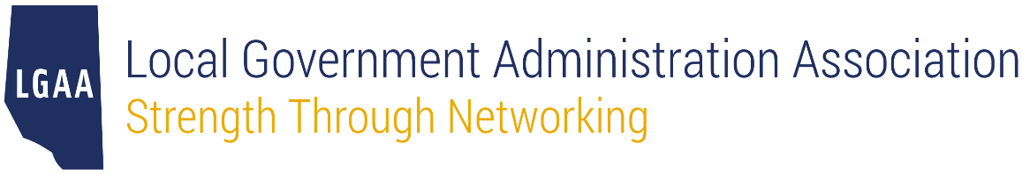

Nomination Form
Municipal Partnership Award

This award is granted to an individual or organization that has made an extraordinary contribution to the Local Government Administration Association of Alberta (LGAA) or the municipal sector in Alberta. There is no requirement to be a member of LGAA to be eligible for this award.

Any person may nominate an individual or organization for this award but may not nominate themselves or an organization they are associated with. Nominators do not need to be a member of LGAA.

The nomination deadline for the 2024 awards is April 30, 2024. To submit your nomination, please email this completed form to info@lgaa.ab.ca by the stated deadline.

- Details of the Nominator
Name
Position
Organization
Email
Phone

- Details of the Nominee (fill out section B if you are nominating a person)
Name
Position
Organization
Email
Phone

- Details of the Nominee (fill out section C if you are nominating an organization)
Organization
Contact Person
Contact Email

Eligibility
Please explain how the nominee has made an extraordinary contribution to the betterment of LGAA or the municipal sector in Alberta.

