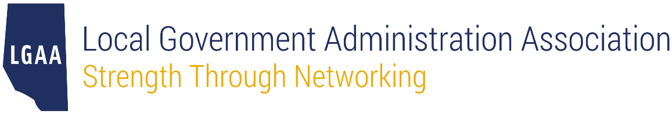

Nomination Form
Life Member Award

The Life Member Award represents the highest honour that can be granted to a member of the Local Government Administration Association of Alberta (LGAA).

The following persons may nominate an individual for the Life Member Award:
- Two Regular Members or two Life Members or a combination of both, or
- One current member of the LGAA Board.

The nomination deadline for the 2023 awards is April 30, 2024. To submit your nomination, please email this completed form to info@lgaa.ab.ca by the stated deadline.

Details of Nominator #1
Name
Position
Organization
Email
Phone

Details of Nominator #2 (not required if Nominator #1 is an LGAA Board member)
Name
Position
Organization
Email
Phone

Details of the Nominee (person being nominated for the award)
Name
Position
Organization
Email
Phone

Eligibility
Please explain how the nominee meets any of the following criteria. The nominee does not need to meet the criteria for all questions.

- Please explain how the nominee has been actively involved with LGAA during their membership including details on the degree and types of contributions.

- Please explain the degree to which the nominee has advanced the goals and objectives of LGAA.

- Please use this space to provide any other information that the LGAA Board of Directors should consider in its review such as the length of time the nominee has worked in the municipal sector or specific achievements.

